Secure Notes Flask Project Documentation
This document contains the complete project overview, architecture, features, setup instructions, folder structure, and implementation details for the Secure Notes Flask Web Application.

1. Project Overview
Secure Notes is a Flask-based secure note-taking web application with authentication, CRUD operations, Flask-Login session handling, password hashing, SQLite database integration, and Bootstrap responsive UI.

2. Technologies Used
- Python
- Flask
- Flask-Login
- Flask-WTF
- Flask-SQLAlchemy
- Flask-Migrate
- SQLite
- Bootstrap 5
- HTML5
- CSS3
- JavaScript

3. Main Features
- User Registration
- User Login & Logout
- Password Hashing
- Session Authentication
- Create Notes
- Edit Notes
- Delete Notes
- View Notes
- User-specific Notes
- Responsive Dashboard
- Profile Page
- CSRF Protection

4. Project Folder Structure
secure_notes/
│
├── app/
│ ├── static/
│ │ ├── style.css
│ │ └── script.js
│ ├── templates/
│ ├── models/
│ ├── __init__.py
│ ├── auth.py
│ ├── forms.py
│ └── extensions.py
├── migrations/
├── instance/
├── requirements.txt
├── run.py
└── README.md

5. Database Models
User Model:
- id
- email
- password
- created_at
Note Model:
- id
- title
- content
- created_at
- user_id

6. Authentication Flow
1. User registers using email and password.
2. Password is hashed before saving.
3. User logs in using Flask-Login.
4. Session is maintained securely.
5. Protected routes require authentication.

7. CRUD Operations
Create: Users can create notes.
Read: Users can view all notes.
Update: Users can edit their notes.
Delete: Users can remove notes permanently.

8. Security Features
- Password hashing using Werkzeug
- Flask-WTF CSRF protection
- Login-required routes
- User ownership validation
- Session management

9. Setup Instructions
1. Create virtual environment
2. Install requirements
3. Run Flask migrations
4. Start Flask server
5. Access application at http://127.0.0.1:5000

10. Flask Commands
flask db migrate -m "Initial migration"
flask db upgrade
flask --app run.py --debug run

11. Future Improvements
- Rich text editor
- Markdown support
- REST API
- Docker deployment
- Password reset system
- Email verification

12. GitHub Submission
Push the project to GitHub and include:
- Source code
- README.md
- Screenshots
- Project documentation

13.Screenshots
Figure 1: Dashboard - Login Successful
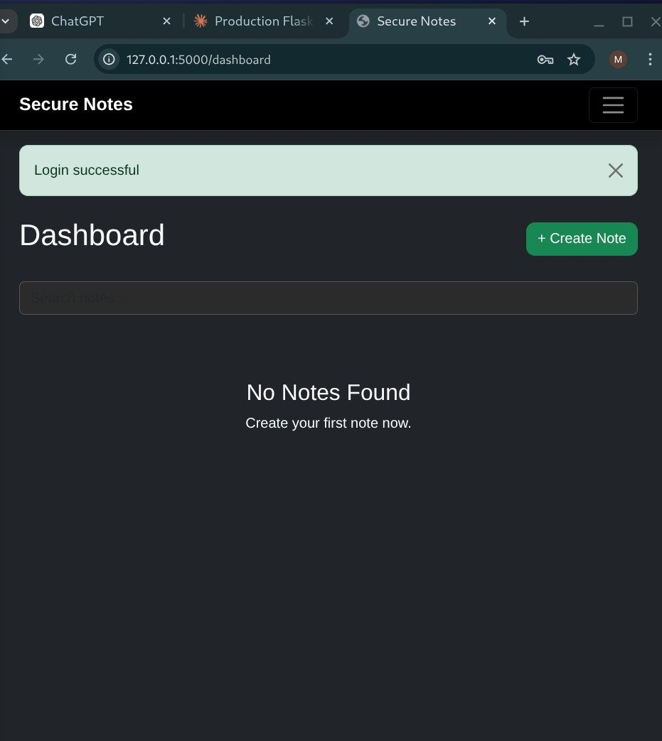

Figure 2: Dashboard - Note Created Successfully
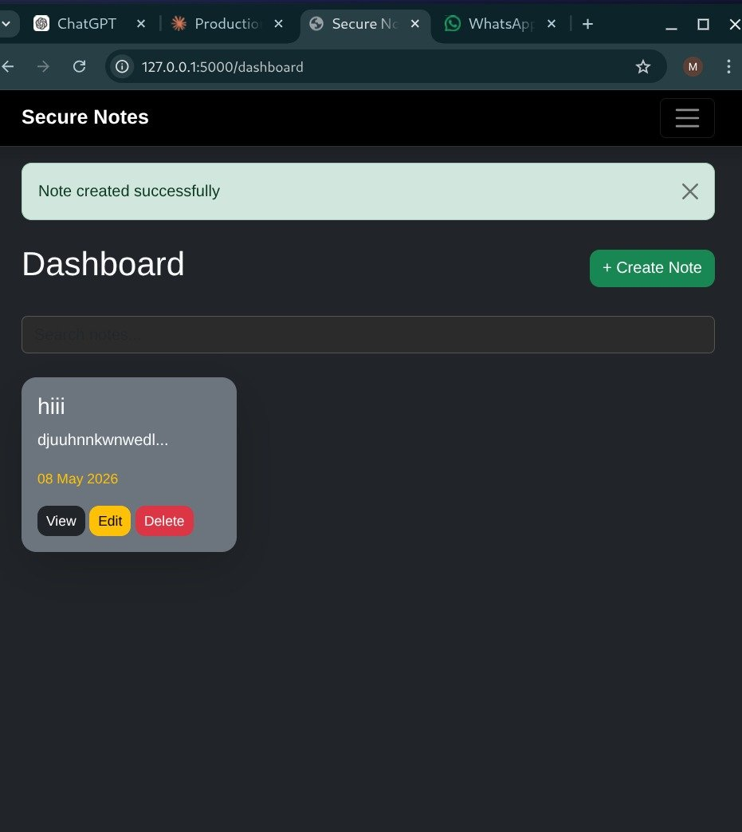

Figure 3: Dashboard - Navigation Menu
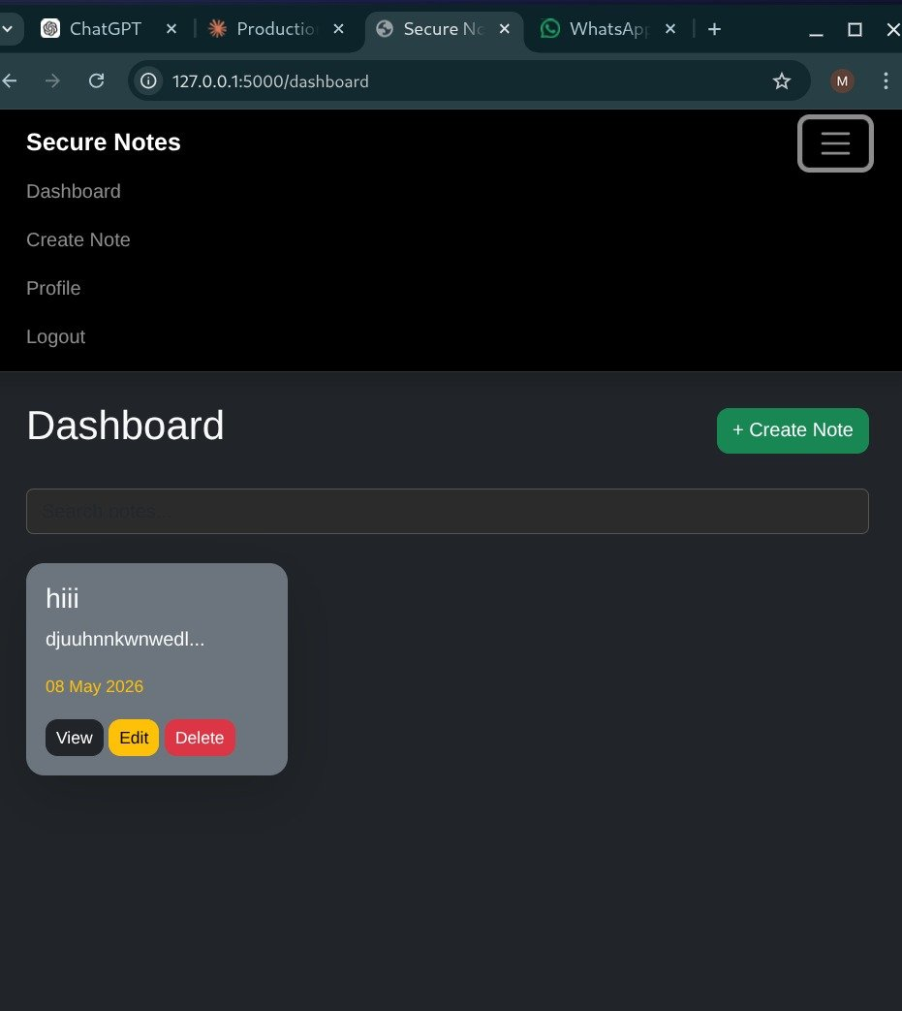

Figure 4: Flask Development Server Running
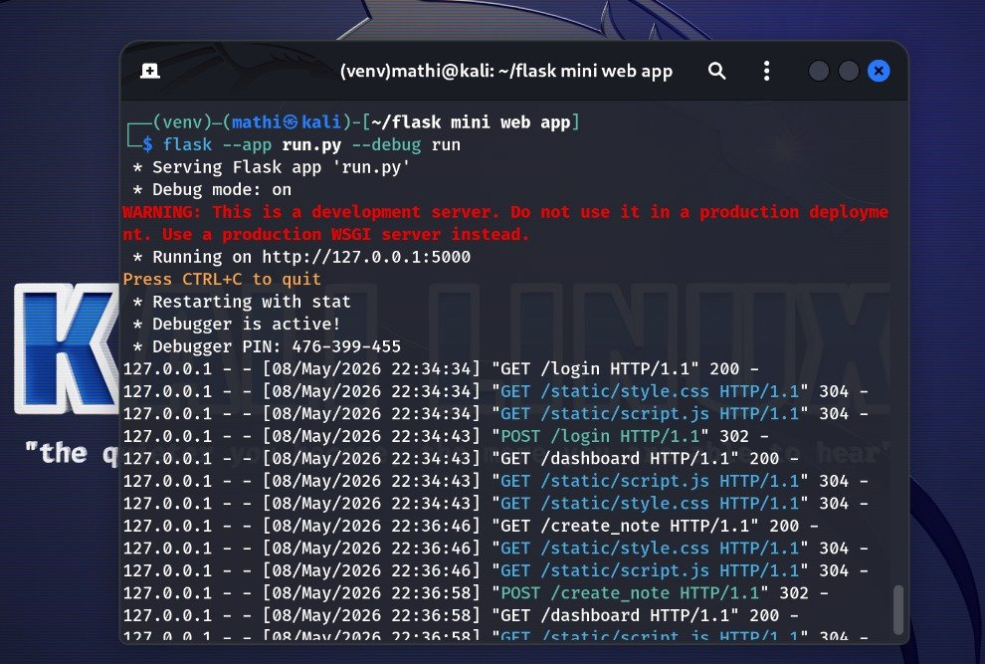

14. Conclusion
This project demonstrates Flask backend development, authentication systems, database management, CRUD functionality, and responsive web application design.
15.AUTHOR
Developed by Mathivadhana V

